**Pseudocode:**

Initialise a clock;

Subtract x and y vector of drag position from bird origin to get distance;

Normalise the vector;

Start clock counting once bird is released (release mouse click);

Move the bird.x in the normalised vector’s direction * speed * dt;

Move the bird.y in the (normalised vector’s direction + clock.asSeconds) * speed * dt;

**UML Before:**

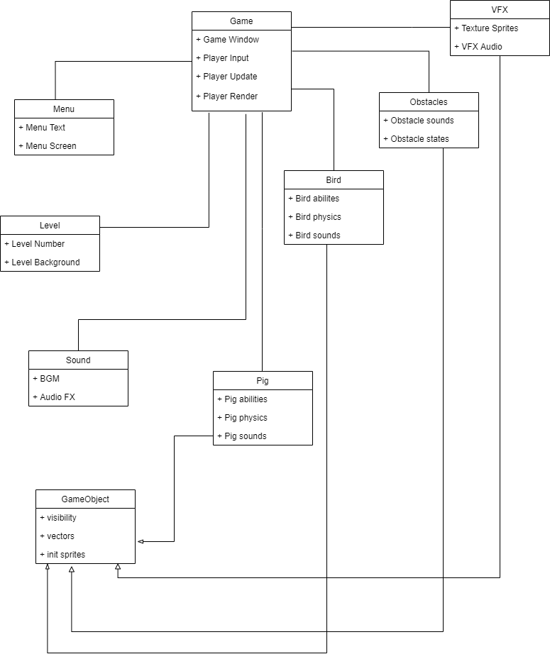

**UML After:**

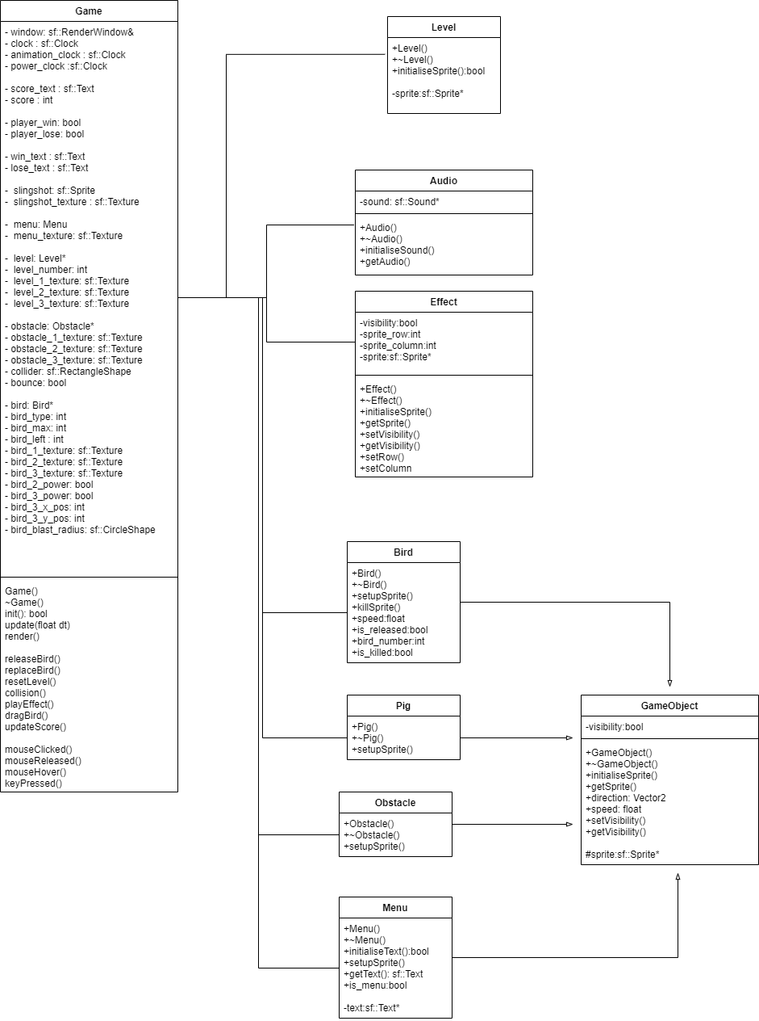

**Discussion:**

-More detailed classes and attributes.

-All sound effects are in one place instead of in different classes.

-BGM is in main game class instead.

-Menu interactables are in main game class.

-Effects do not inherit GameObject.